Posted 08/02/2012 at 8:09 am by JAV

Town Hall Building Committee

DRAFT Agenda
Fireplace Room, Old Library
Tuesday August 7, 2012
6:00 PM

- Approve minutes

- Approve invoices

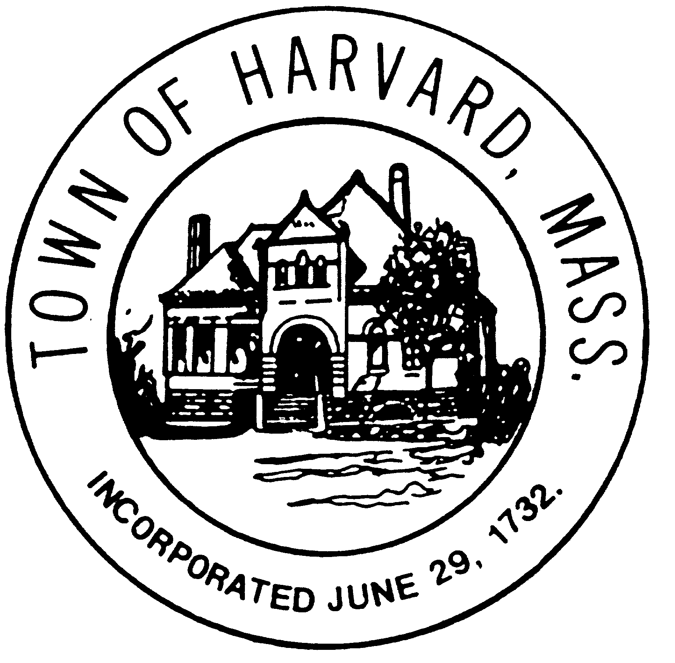
- Final approval of DTI agreement if needed

- Approval of LLB agreement if ready

- Discussion in preparation for meeting with the Board of Selectmen

- Agenda and date for next meeting(s)

- New business

